MOTION CONTROLLER PCB

- PARTS:

QUANTITY: PART #: NOMENCLATURE: LENGTH:

2 PER MACHINE 14046- CAP, ELEC., 220μF, 16V N/A

2 PER MACHINE 13521- HEADER, STR., 50-PIN N/A

1 PER MACHINE 17433-1L HEADER, RT. ANGLE, 10-PIN N/A

1 PER MACHINE 17463-5 HEADER, STR., 26-PIN N/A

1 PER MACHINE 17628- CONNECTOR, PCB HEADER, STR. N/A

2 PER MACHINE 17680- CONNECTOR, DB37, MALE N/A

2 PER MACHINE 10463- IC, -26LS32, 4 CH. CONVERTER N/A

9 PER MACHINE 18727- ARRAY, LED, 4X, YELLOW N/A

5 PER MACHINE 16246- NETWORK, RESISTOR, 330Ω, 10-PIN N/A

5 PER MACHINE 10234- IC, 74LS244, OCTAL BUS DRIVER N/A

1 PER MACHINE 217003-3 PCB, BLANK, MOTION CONTROLLER N/A

1 PER MACHINE 17463-1L HEADER, STR., 10-PIN N/A

2 PER MACHINE 17419-8 HEADER, 8-POS, STR. N/A

1 PER MACHINE 17463-4 HEADER, STR., 20-PIN N/A

1 PER MACHINE 17419-12 HEADER, 12-PIN, W / LOCK N/A

- ASSEMBLY:

- INSERT AND SOLDER THE SMALLCAPACITORS TO THE BOARD.

- INSERT AND SOLDER THE ICS TO THE BOARD.

- INSERT AND SOLDER THE RESISTOR NETWORKS TO THE BOARD.

NOTE 1
IT IS CRITICAL TO INSERT THE RESISTOR NETWORKS WITH PIN #1 AT THE SQUARE HOLES.

- INSERT AND SOLDER THE RIGHT ANGLE HEADER TO THE BOARD.

- INSERT AND SOLDER THE LED ARRAYS TO THE BOARD.

- INSERT AND SOLDER THE WHITE HEADERS TO THE BOARD.

- INSERT AND SOLDER THE LARGE CAPACITORS TO THE BOARD.

NOTE 2
IT IS CRITICAL TO INSERT THE LARGE CAPACITORS WITH THE CORRECT POLARITY.

- INSERT AND SOLDER THE GRAY HEADERS TO THE BOARD.

I. INSERT AND SOLDER THE DB37 CONNECTORS TO THE BOARD.

NOTE 3
SEE DIAGRAM 1 FOR BOARD LAYOUT.
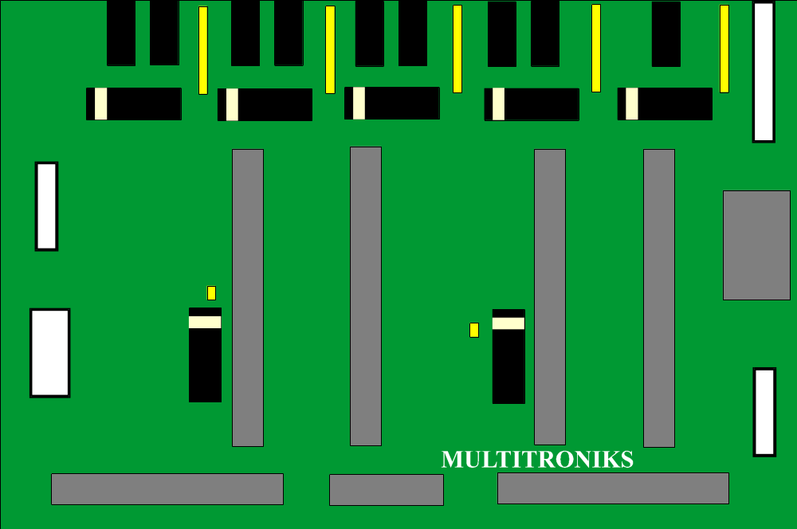
DIAGRAM 1

